|  |  |
| --- | --- |
| Internship Project Title | TCS ion RIO-125: Automate Detection and Recognition of Grammatical Errors |
| Name of the Company | TCS iON |
| Name of the Industry Mentor | Snehal Tandel |
| Name of the Institute | University College of Engineering Arni, Thatchur |

|  |  |  |  |  |  |  |
| --- | --- | --- | --- | --- | --- | --- |
| Start Date | End Date | | Total Effort (hrs.) | | Project Environment | Tools used |
| 19.04.2023 | 19.07.2021 | | 25 | | Jupyter Notebook | Python3 |
| Milestone # | 1 | Milestone: | | Making Requirements ready and importing modules | | |

**TABLE OF CONTENT**

|  |  |
| --- | --- |
| S. No | TOPICS |
| 1. | Acknowledgement |
| 2. | Objective |
| 3. | Introduction |
| 4. | Internship Activities |
| 5. | Approach/ Methodology |
| 6. | Outcome |
| 7. | Link to the code and Executable file |
| 8. | Conclusion |

1. **ACKNOWLEDGEMENTS**

I am conveying my sincere gratitude towards my Industry Mentor, Snehal Tandel and Academic Mentor, Mrs. Shoba for helping me throughout this project till now and providing me this wonderful platform to complete this project. I am thankful for answering my queries at every phase of the project. I also want to thank all my friends who helped me with valuable suggestions during this project.

1. **OBJECTIVE**

The objective of this Internship is to create a model that Detects and recognize the Grammatical errors of the sentences in the English language with the help of the Machine Learning concepts.

1. **INTRODUCTION**

In TCS Ion Rio-125 internship, I have selected the Machine Learning Project on Automate Detection and Recognition of Grammatical Errors. In this project, I have to create a model that should detects the grammatical errors in the given sentences which is in English language. The project includes collection of dataset, data pre-processing, analyses of data, splitting of train and train data and creation of model.

1. **INTERNSHIP ACTIVITIES**
   * Watched all the welcome kit videos.
   * Attended the RIO – pre-assessment test.
   * Went through the day-wise plan.
   * Read and learnt some concepts mentioned in the project reference material.
   * Read the industry project material.
   * Watched webinar 1.
   * Watched webinar 2.
   * Daily checking for announcement in Digital Discussion Room.
   * Created a GitHub Repository for Project.
   * Searched and found out a proper dataset for this project.
   * Wrote activity reports.
   * Checked and clarified the data set whether it has enough data for the project.
   * Read articles and find out how to clean and sanitize the data.
2. **APPROACH / METHODOLOGY**

The approach I took for this internship project for completing the 1st milestone is firstly understanding the concepts and the making requirements ready. Reading articles and watching videos helped in gaining knowledge about the requirements for the project. Jupyter Notebook has been used for doing the programming. A GitHub repository has been created for the Project.

1. **OUTCOME**

After the 1st milestone of this internship project, I have learned about Natural Language Processing and understood how it works. And I have installed some libraries and imported it in the program for dataset pre-processing and for creating detection model and learnt the uses of the libraries that are used in this project.

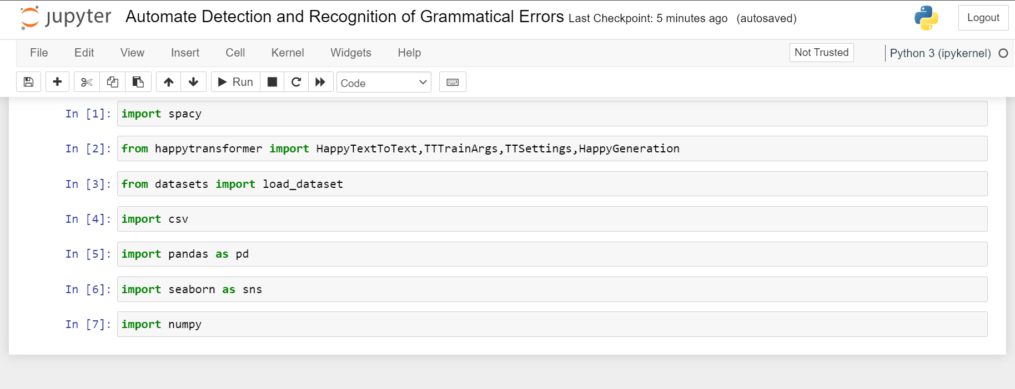

1. **LINK TO CODE AND EXECUTABLE FILE**

* Link to the code:

<https://github.com/Yokesh-Murugan/TCS-iON-Rio-125/blob/main/Automate%20Detection%20and%20Recognition%20of%20Grammatical%20Errors.ipynb>

1. **CONCLUSION**

The project is further developed for the model creation and detection and recognition of grammatical errors. The dataset has to be analyzed and EDA is processed with the dataset. After that, the process of splitting data and finding patterns in the data is to be completed.